# 题目

路径 被定义为一条从树中任意节点出发，沿父节点-子节点连接，达到任意节点的序列。同一个节点在一条路径序列中 至多出现一次 。该路径至少包含一个节点，且不一定经过根节点。

路径和 是路径中各节点值的总和。

给定一个二叉树的根节点 root ，返回其 最大路径和，即所有路径上节点值之和的最大值。

示例 1：

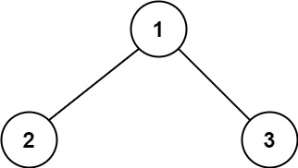

输入：root = [1,2,3]

输出：6

解释：最优路径是 2 -> 1 -> 3 ，路径和为 2 + 1 + 3 = 6

示例 2：

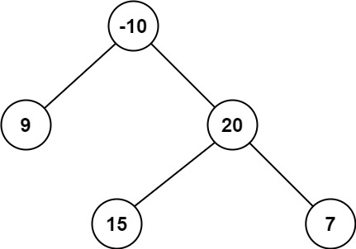

输入：root = [-10,9,20,null,null,15,7]

输出：42

解释：最优路径是 15 -> 20 -> 7 ，路径和为 15 + 20 + 7 = 42

提示：

树中节点数目范围是 [1, 3 * 104]

-1000 <= Node.val <= 1000

注意：本题与主站 124 题相同：

https://leetcode-cn.com/problems/binary-tree-maximum-path-sum/

# 分析

[/**](https://leetcode-cn.com/problems/jC7MId/)

[* Definition for a binary tree node.](https://leetcode-cn.com/problems/jC7MId/)

[* struct TreeNode {](https://leetcode-cn.com/problems/jC7MId/)

[*     int val;](https://leetcode-cn.com/problems/jC7MId/)

[*     TreeNode *left;](https://leetcode-cn.com/problems/jC7MId/)

[*     TreeNode *right;](https://leetcode-cn.com/problems/jC7MId/)

[*     TreeNode() : val(0), left(nullptr), right(nullptr) {}](https://leetcode-cn.com/problems/jC7MId/)

[*     TreeNode(int x) : val(x), left(nullptr), right(nullptr) {}](https://leetcode-cn.com/problems/jC7MId/)

[*     TreeNode(int x, TreeNode *left, TreeNode *right) : val(x), left(left), right(right) {}](https://leetcode-cn.com/problems/jC7MId/)

[* };](https://leetcode-cn.com/problems/jC7MId/)

[*/](https://leetcode-cn.com/problems/jC7MId/)

[class Solution {](https://leetcode-cn.com/problems/jC7MId/)

[private:](https://leetcode-cn.com/problems/jC7MId/)

[int ret;](https://leetcode-cn.com/problems/jC7MId/)

[public:](https://leetcode-cn.com/problems/jC7MId/)

[int maxPathSum(TreeNode* root) {](https://leetcode-cn.com/problems/jC7MId/)

[ret = INT_MIN;](https://leetcode-cn.com/problems/jC7MId/)

[dfs(root);](https://leetcode-cn.com/problems/jC7MId/)

[return ret;](https://leetcode-cn.com/problems/jC7MId/)

[}](https://leetcode-cn.com/problems/jC7MId/)

[int dfs(TreeNode* root) {](https://leetcode-cn.com/problems/jC7MId/)

[if (root == nullptr) {](https://leetcode-cn.com/problems/jC7MId/)

[return 0;](https://leetcode-cn.com/problems/jC7MId/)

[}](https://leetcode-cn.com/problems/jC7MId/)

[int left = max(0, dfs(root->left));](https://leetcode-cn.com/problems/jC7MId/)

[int right = max(0, dfs(root->right));](https://leetcode-cn.com/problems/jC7MId/)

[ret = max(ret, left + right + root->val);](https://leetcode-cn.com/problems/jC7MId/)

[return root->val + max(left, right);](https://leetcode-cn.com/problems/jC7MId/)

[}](https://leetcode-cn.com/problems/jC7MId/)

[};](https://leetcode-cn.com/problems/jC7MId/)